Name | Aaron Soong Yujien
Student ID | 34076832
Studio Session | Friday 4–6pm

Part A: URL of the Visualisation
https://asoo0015-glitch.github.io/FIT3179-DV2/dv2/

Part B: Domain Description
Describe your domain chosen for DV II
Australian Historical Newspapers. The visualisation investigates the historical newspaper archive in Australia, using Trove. Trove is the National Library of Australia’s digitised newspaper collection – hence I used publicly available records. It compares publication trends over time (titles launched, in print and closed, by state and town, from 1803 to 1954) and links them to settlement, the gold rushes, the wars and the non-English press, to show how newspapers reflect Australian society.

Describe the Why and Who aspects of your DV II
Why. Trove is where many Australians go to research the past, but it is not a neutral record of the press. Its counts reflect what was printed, what has been digitised and what copyright allows. The visualisation tells the story of how the press grew with each wave of settlement, spread out from the capital cities and then thinned out, and it shows readers where the data can mislead them. Two examples are a bulge in the 1910s caused by Victorian local papers that Trove holds only for 1914–1918, and an 88% drop in articles between 1954 and 1955 that comes from the copyright cut-off, not from papers closing. It turns a table of 1,831 titles and 251 million articles into patterns that are hard to see otherwise.
Who. The average Australian: a reader who is curious about history and may have used Trove, but has no background in statistics or data. The text avoids jargon and explains each measure the first time it appears (“titles in print”, “titles per 100,000 km²”, “1929 = 100” and the log scale). The page is built for presentation, not exploration: five chapters, one linked year selector and annotations that point out what to notice.

Describe the “What” aspect of your DV II
Sources. (1) Trove newspaper totals (CC0), harvested from the Trove API by Tim Sherratt and published in the GLAM Workbench (github.com/wragge/trove-newspaper-totals): articles per year, per year and state, and per newspaper title (1,833 titles with start year, end year and state), plus a count of articles with user corrections. (2) Newspaper titles harvested from web archives (CC0), Tim Sherratt, GLAM Workbench, harvested on 21 January 2022: lists of titles as they first appeared in archived copies of Trove’s title list, 2009–2022. (3) Trove newspapers with non-English language content (CC0), Tim Sherratt, GLAM Workbench: titles with detected languages. (4) Coordinates for each title’s place of publication, based on the GLAM Workbench file trove-newspaper-titles-locations.csv. (5) Australian Bureau of Statistics, Australian Statistical Geography Standard Edition 3: State and Territory boundaries (2021, GDA94) and areas, © Commonwealth of Australia, CC BY 4.0, simplified and converted to TopoJSON with Mapshaper. All Trove data comes from the National Library of Australia (trove.nla.gov.au).
Relevance. Together these cover the Australian press up to 1954, with state and place, so they show growth, geography and decline directly. The ABS data supplies the map shapes and state areas, so title counts can be compared fairly between large and small states.
Creation process. I prepared the data with Python and pandas (scripts are in the repository). I kept the 1,831 titles that have both a start and an end year, and counted a title as in print in every year from its start to its end, up to 1954. Titles were matched to their place and coordinates (130 have no place and are left off the town and square maps). The 86 Victorian local papers that Trove holds only for 1914–1918 are flagged so they can be shown separately. Title counts were divided by state area to get titles per 100,000 km², each state’s article count was indexed to its own 1929 total, and the year each title record first appeared in the archived title lists was counted for the heatmap. For languages, I kept titles that began by 1954 and where a language other than English made up at least a fifth of the sampled text (39 titles, 13 languages; Latin was dropped as likely OCR misreads). The limits of the data are stated on the page.

Describe the “How” aspect of your DV II
The page has 15 charts in five chapters, and each idiom answers one question a general reader would ask. Position on a common scale carries the main comparison in every chart. Colour marks the state (the same colour for each state in every chart, from a colour-blind-safe palette) or a single highlight, and annotations say what to notice.
Stacked area chart (chapter 1): How did articles grow and which states drove it? Total height is the national count, band thickness is each state, and dashed lines mark the gold rushes, Federation and the wars.
Diverging butterfly bar chart (chapter 2): Were more papers opening or closing? Launches extend left and closures right from one zero line, so the net loss after the 1920s shows at a glance. Tan segments separate the 1914–1918 slices.
Gantt chart (chapter 2): Which papers lasted longest? Each bar is one title’s run on a shared year axis, with a line at 1954 where Trove’s coverage ends.
Dot maps in small multiples (chapter 3): Where did new titles start? One dot per title in three eras, with colour separating capital cities from regional towns.
Brush overview chart (chapter 3): Which years should the maps show? Dragging a window over this chart, or pressing a preset button, updates the three maps below it.
Proportional symbol map (chapter 3): Where were the presses? Circle area shows titles per town and colour shows state, with a zoom menu for crowded areas.
Choropleth map (chapter 3): Which states had the most papers for their size? Shading shows titles per 100,000 km², which makes large and small states comparable.
Square-binned map (chapter 3): Where were papers thickest? Equal 200 km squares add up circles that overlap on the symbol map.
Bump chart (chapter 3): How did states’ ranks change? Vertical position is rank by titles in print each decade, with direct labels instead of a legend.
Lollipop chart (chapter 3): Which towns had the most titles? The top 15 towns are sorted, with Sydney highlighted.
Indexed line chart (chapter 4): How far did each state’s record fall? Every state is set to 100 in 1929, which compares states of very different size, and callouts mark 1931 and 1943.
Dumbbell chart (chapter 4): Where did the press move? Two dots per state (1900 and 1930) are joined by a line, so line length shows the change.
Lollipop chart of languages (chapter 5): Which other languages were printed? Dots show the number of titles per language, sorted from most to fewest.
Annotated line chart on a log scale (chapter 5): Why do articles collapse after 1954? One axis fits 1850 to 2023, and a shaded zone marks the copyright cut-off.
Heatmap (chapter 5): When did Trove add titles, by state? Rows are states, columns are years, and darker squares mean more titles.
Special features. One year selector, built from a Vega-Lite brush and a short JavaScript file, links the symbol, choropleth and square maps. The 200 km square grid was generated by my own Python script so that every square covers the same real area (40,000 km²). All maps share one conic equal-area projection. The circle-size legend is custom, and the 1914–1918 Victorian slices are flagged and shown separately in two charts. Titles use Merriweather and text uses Verdana, with a blackletter masthead to suit the newspaper theme. The JSON for every chart is readable in the dv2/js folder of the repository.
AI acknowledgement.
No AI was used in the DV2 assignment.

Part C: Sketch
A URL to a PDF document with an image of your sketch on your GitHub account.
Tip: Test your URL in incognito mode to ensure it is a working URL

https://github.com/asoo0015-glitch/FIT3179-DV2/blob/main/dv2/documents/DV2%20Sketch%20-%20Aaron.pdf 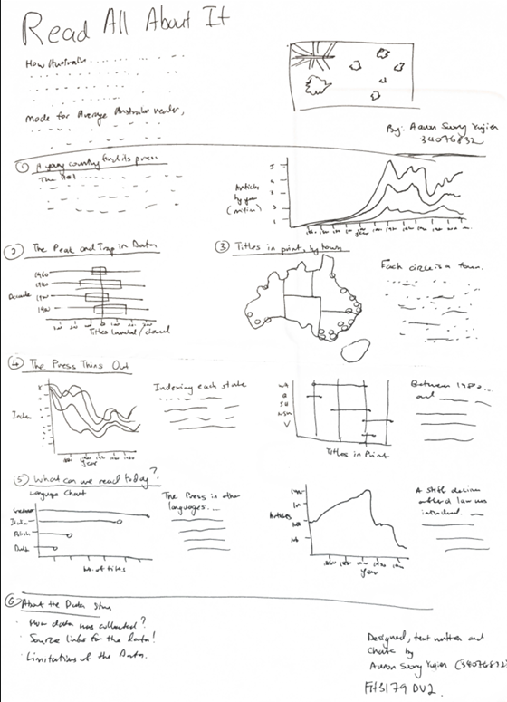

Part D: Full-size screenshot of your DV II
